OnCast Technologies Recruitment Process Assessment
Candidate: Eduardo Hoeller
Date Delivered: 06/04/2015
Estimated Time Taken: 3h30

This document contains the requested information regarding the design choices made during the implementation stage of the assessment.

Class Diagram
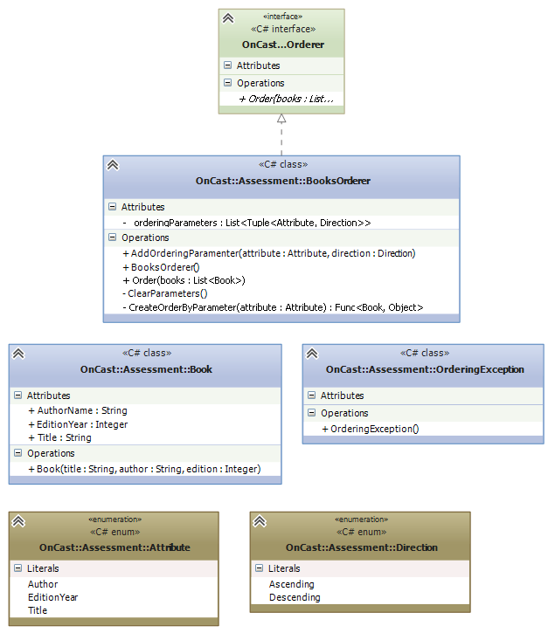

I’ll comment on the most important decisions that made this simple design the one to be chosen.

Direction and Attribute
Having the order method in the interface being restricted to only one parameter (the list of books) it was necessary to find a way to define the ordering parameters elsewhere. The most straightforward solution proved to be a simple field in the BooksOrderer class, _orderingParameters. With that, the obvious, more elegant way to define such parameters were enums, namely, Direction and Attribute. Making _orderingParamenter a List<Tuple<Attribute, Direction>> then proved to be the most sensible way to encapsulate this data in a logical and readable fashion.

Ordering Lists
LINQ is a staple facility in .NET for managing. The extension methods OrderBy and ThenBy were the obvious choices when it came to implementing the BooksOrderer class main feature – order books. OrderBy is an extension method for List objects and returns an IOrderedEnumerable. It orders a list given a Func<T1,T2> delegate, which is nothing more than a LINQ Predicate defining which attribute the list must be ordered over. The ThenBy extension method implementation of the IOrderedEnuberable member of the same name works the just like OrderBy, and is cut for subsequent orders after the initial one. That’s actually a rather complicated explanation for a very simple thing: C# can order lists in just one line of code.

LINQ also provides two other extension methods OrderByDescending and ThenByDescending. The choice between calling an Ascending or Descending method relies only in checking the direction of the first Tuple in the _orderingParameters list with a simple conditional (if/else).

Namespace
I’d like to comment on that namespace: although the assessment suggested using “br.com.oncast”, that’s standard for Java packages whereas .NET namespaces usually go CompanyName.Product<.Module.SoOn>. I opted for something akin to this standard.

Class Book
I defined their property setters as private and provided a constructor, as it makes more sense in a design standpoint.

